# Maximizing the Final Element

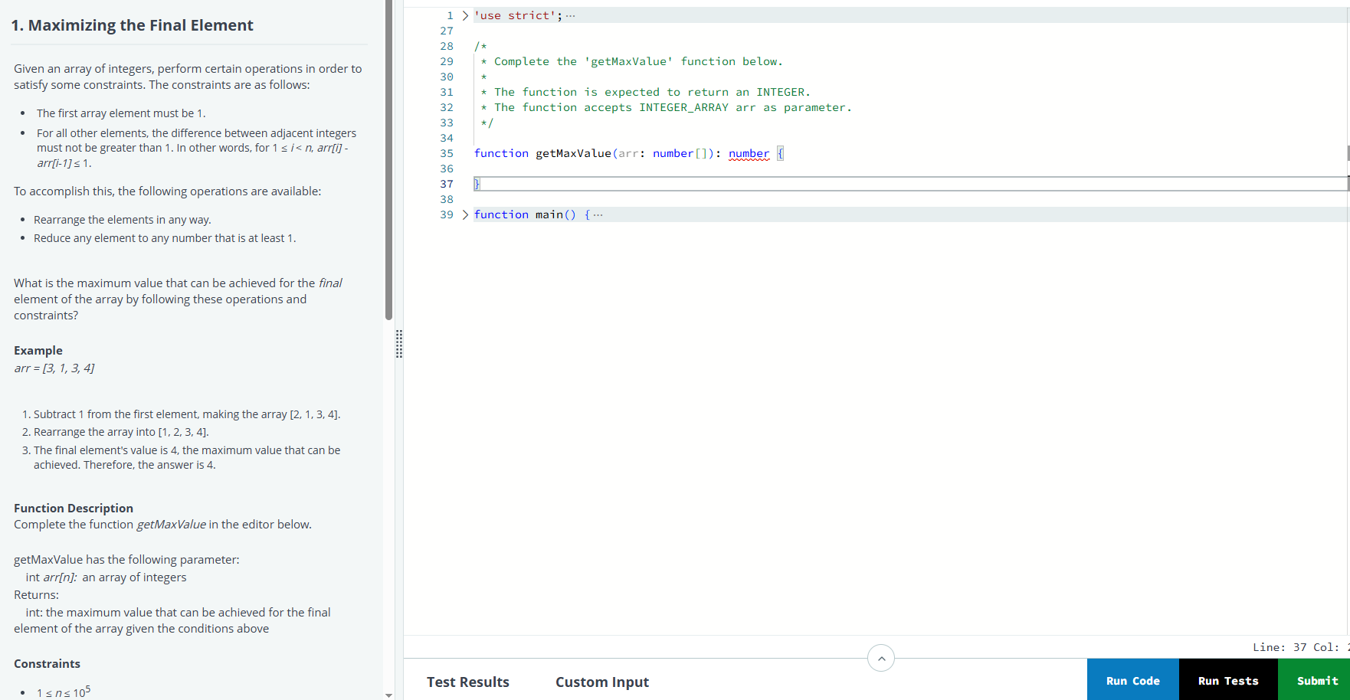

function getMaxValue(arr: number[]): number {

arr.sort((a, b) => a - b); // Step 1: Sort the array

arr[0] = 1; // Step 2: First element must be 1

// Step 3: Adjust rest of the array

for (let i = 1; i < arr.length; i++) {

arr[i] = Math.min(arr[i], arr[i - 1] + 1);

}

return arr[arr.length - 1]; // Step 4: Final value is the result

}

# Youngest Employees

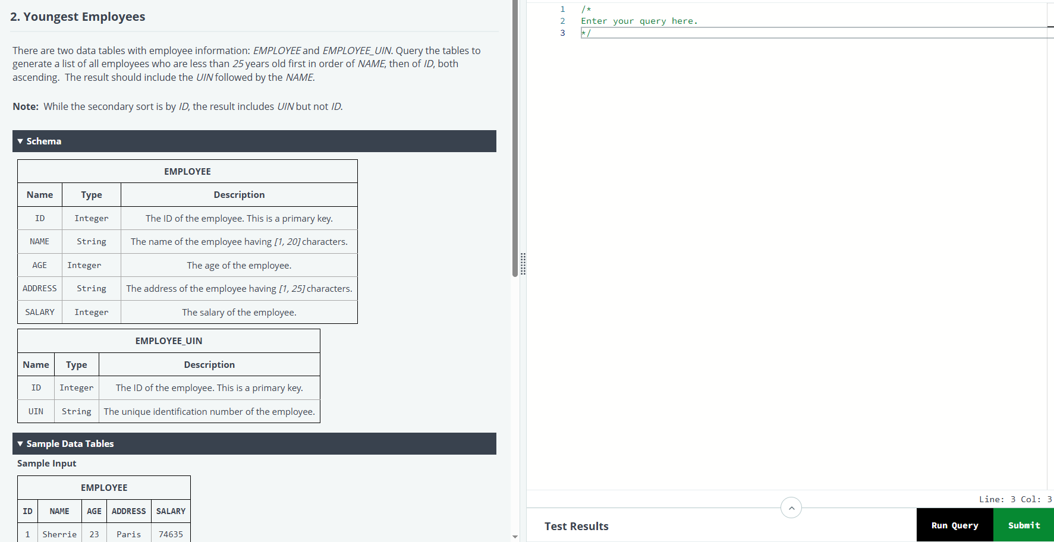

SELECT u.UIN, e.NAME

FROM EMPLOYEE e

JOIN EMPLOYEE_UIN u ON e.ID = u.ID

WHERE e.AGE < 25

ORDER BY e.NAME ASC, e.ID ASC;

# Meaning of Space Complexity



# SQL Order of Operations

